**POWER BI CLOUD – Level 1**

**Power BI Cloud is a Virtual Environment to store (host) and secure the Reports that are designed using Power BI Desktop. We can share the reports from cloud to end users and perform Data Refresh.**

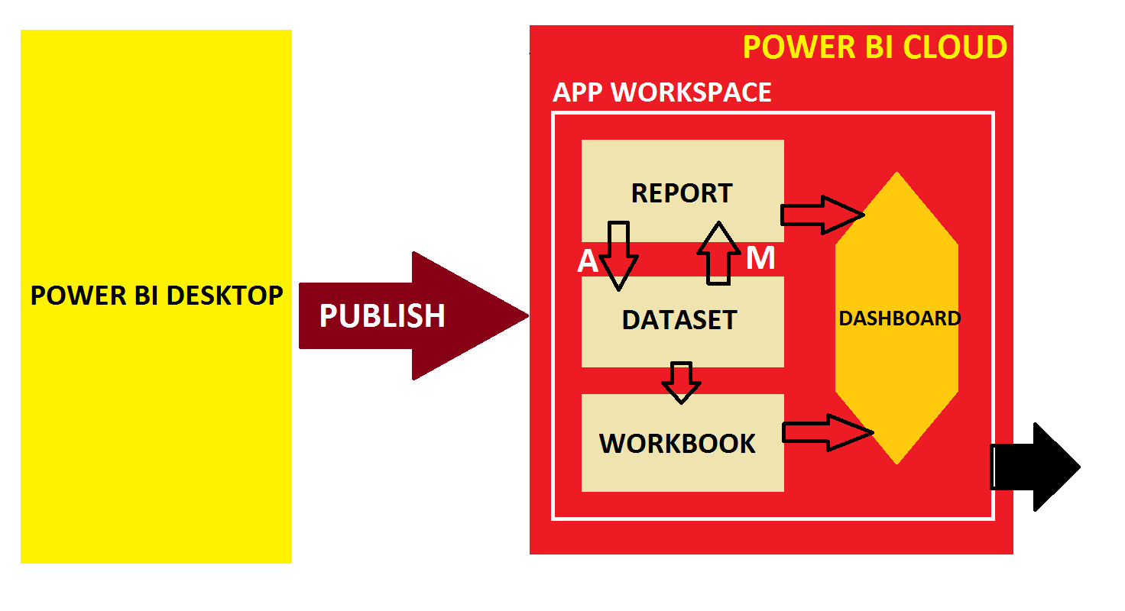

**ITEM #1: WHAT ARE COMPONENTS IN POWER BI CLOUD ARCHITECTURE?**

|  |  |  |
| --- | --- | --- |
| **1** | **REPORTS** | REPRESENT POWER BI REPORTS DESIGNED FROM POWER DESKTOP (PBIX) |
| **2** | **DATASETS** | TO REPRESENT THE DATA SOURCE(S) & QUERIES USED FOR REPORTING |
| **3** | **DASHBOARDS** | TO GROUP MULTIPLE REPORTS OR SPLIT A SINGLE REPORT FOR USER ACCESS |
| **4** | **TILES** | ACTUAL ITEMS IN THE DASHBOARDS : REPORT PAGES, IMAGES, VIDEOS, ... |
| **5** | **WORKBOOKS** | A SPECIAL TYPE OF **EXCEL ONLINE** DATASET, UPLOADED TO CLOUD.  USED TO GENERATE DASHBOARDS WITHOUT CREATING REPORTS. |
| **6** | **GATEWAYS** | POWER BI COMPONENTS, INSTALLED AT THE DATA SOURCE DATA CENTER TO SYNCHRONIZE (REFRESH) THE REPORT DATA WITH POWER BI CLOUD. |
| **7** | **SUBSCRIPTIONS** | AUTOMATED EMAILS TO END USERS BASED ON A SCHEDULE. Ex: Every hour |
| **8** | **ALERTS** | AUTOMATED EMAILS TO USERS BASED ON DATA VALUES. Ex: Sales < 1m |
| **9** | **APP WORKSPACE** | THIS IS A CONTAINER TO STORE ALL ABOVE ENTITIES IN A SECURED VIRTUAL DIRECTORY (SPACE) IN POWER BI CLOUD. |

**Implementation Steps:**

**Step 1: Create Power BI Cloud Account >> Login**

**Step 2: Create a App Workspace [Container to store Reports & Data sets]**

**Step 3: Publish the Reports. This auto creates Datasets in Cloud**

**Step 4: Create new Reports and Dashboards in Cloud**

**Step 5: Create new Workbooks (Excel Online) and Data Flows [Power Query]**

**Step 6: Configure Gateway For Data Refresh**

**Step 7: Embed all above entities into Power BI App and Publish.**

**Share App to End Users. Subscribe, Configure Alerts**

**ITEM #1: HOW TO LOGIN FOR POWER BI CLOUD ACCOUNT?**

GO TO <http://app.powerbi.com>

LOGIN : pbi89@sqlschool.com fchums123$$

**ITEM #2: HOW TO CREATE APP WORKSPACE?**

CLICK @ WORKSPACE (LEFT) > "**CREATE A WORKSPACE**" > SPECIFY NAME > SAVE.

**ITEM #3: HOW TO PUBLISH REPORTS FROM POWER BI DESKTOP TO POWER BI CLOUD?**

FROM POWER BI DESKTOP TOOL : DESIGN / OPEN **REPORT** > TOP : RIGHT CORNER > SIGN IN TO POWER BI CLOUD. TOP RIGHT CORNER > **PUBLISH** > THIS PROMPTS FOR WORKSPACE > SELECT YOUR WORKSPACE > PUBLISH. THIS PUBLISHES THE REPORT TO POWER BI SERVICE (CLOUD).

ONE **DATASET** IS AUTO CREATED IN POWER BI CLOUD FOR THIS REPORT.

**ITEM #4: HOW TO VERIFY YOUR PUBLISHED REPORTS?**

FROM POWER BI SERVICE (CLOUD) > GO TO WORKSPACE CREATED ABOVE > WE SEE ONE DEFAULT "LANDING PAGE". THIS PAGE INCLUDES ALL ITEMS IN THE WORKSPACE.

WE SEE THE ABOVE PUBLISHED REPORT + AUTO GENERATED DATASET

CONTENT: THIS TAB SHOWS REPORTS UPLOADED TO CLOUD

DATASETS + DATAFLOWS: THIS TAB SHOWS DATASETS AUTO GENERATED FROM REPORTS

**ITEM #5: HOW TO CREATE NEW REPORT IN POWER BI CLOUD ?**

FROM POWER BI SERVICE (CLOUD) > GO TO ABOVE WORKSPACE > DATASETS + DATA FLOWS >

SELECT ABOVE DATASET > MORE OPTIONS: CREATE REPORT.

DESIGN REPORT > SAVE. THIS REPORT IS SAVED IN POWER BI CLOUD.

TO VERIFY : GO TO "ALL" TAB OR "CONTENT" TAB. WE WOULD SEE THE REPORT LISTED.

**ITEM #6: HOW TO VERIFY THE REPORT - DATASET DEPENDANCIES IN POWER BI CLOUD ?**

FROM POWER BI CLOUD > APP WORKSPACE > TOOLBAR > VIEW : DROPDOWN > LINEAGE

THEN WE SEE EVERY DATA SET AND THE CORRESPONDING REPORTS

TO RESET THE PAGE : GO TO TOOLBAR > VIEW : DROPDOWN > LIST

**ITEM #7: WHAT ARE DASHBOARDS IN POWER BI CLOUD?**

DASHBOARDS ARE ENTITIES IN POWER BI CLOUD THAT CONTAIN VISUALS FROM VARIOUS REPORTS. THESE DASHBOARDS ARE SHARED TO END USERS.

**ITEM #8: WHAT ARE TILES IN DASHBOARDS?**

TILES ARE INDIVIDUAL VISUALS OR MEDIA (IMAGES, VIDEOS) WE SEE IN THE DASHBOARDS.

**ITEM #9: HOW TO CREATE DASHBOARDS FOR END USER ACCESS?**

POWER BI SERVICE (CLOUD) > WORKSPACE > TOOLBAR : + NEW > CREATE DASHBOARD > SPECIFY A NAME > OK.

**ITEM #10: HOW TO PIN INDIVIDUAL VISUALS INTO DASHBOARD?**

IN APP WORKSPACE > "CONTENTS" TAB > CLICK @ REQUIRED REPORT > SELECT OR HIGHLIGHT A

VISUAL > **PIN**. THIS PROMPTS FOR SELECTION OF DASHBOARD > SELECT > OK.

**ITEM #11: HOW TO PIN ENTIRE PAGE TO DASHBOARD?**

IN APP WORKSPACE > "CONENTS" TAB > CLICK @ REQUIRED REPORT > SELECT REQUIRED PAGE > CLICK @ ... [MORE OPTIONS] > **PIN LIVE PAGE** > SELECT THE DASHBOARD > OK.

**ITEM #12: HOW TO VERIY ABOVE CONTENTS IN THE DASHBOARD?**

APP WORKSPACE > CONTENTS > CLICK @ DASHBOARD > WE SEE THE ABOVE PINNED ITEMS

**ITEM #13: WHAT IS THE DIFFERENCE BETWEEN PIN VISUAL AND PIN LIVE PAGE?**

PIN VISUAL : ANY CLICK ON THIS TILE IN THE DASHBOARD WILL HYPERLINK TO REPORT.

PIN LIVE PAGE : ANY CLICK ON THIS ANY VISUAL WITHIN THIS TILE IN THE DASHBOARD WILL RESULT IN VISUAL INTERACTION AND FILTERING.

**ITEM #14: WHAT IS THE Q** & **A OPTION IN DASHBOARD?**

THIS IS CALLED "CORTANA"

WE TYPE CATEGORY, SUMMARY VALUES INCLUDING THE VISUAL NAME. WE GET A VISUAL.

THE RESULTING VISUAL CAN BE PINNED TO A DASHBOARD.

EXAMPLE: COUNTRY BY SALES 2016 IN TREEMAP

**ITEM #15: WHAT ARE THE DIFFERENT DASHBOARD ACTIONS (OPERATIONS) IN CLOUD?**

FILE: SAVE A COPY, PRINT, PERFORMANCE INSPECTOR, SETTINGS

SHARE : SHARE DASHBOARD TO OTHER POWER BI USERS. THEY CAN READ, REASHARE

CHAT @ TEAMS

COMMENTS

SUBSCRIBE: SEND AUTOMATED EMAILS BASED ON A PREDEFINED SCHEDULE

EDIT: ADD TILE [IMAGE OR VIDEO OR STREAMING DATASET]

DASHBOARD THEME

MOBILE VIEW

SEE RELATED CONTENT

VIEW LIENAGE: TO SHOW THE DEPENDANCIES OF THE DASHBOARD WITH DATASET, REPORTS

USAGE METRICS: TO REPORT THE USAGE, ACCESS, VIEWERS, VIEWS, ETC..

SET AS FEATURED: TO SET DASHBOARD AS THE DEFAULT LANDING PAGE

**ITEM #16: HOW TO ADD NEW IMAGE TILE TO A DASHBOARD?**

APP WORKSPACE > DASHBOARD > CLICK @ ... [MORE OPTIONS> "**ADD TILE"** > SELECT **IMAGE** > NEXT > IMAGE SOURCE: http://sqlschool.com/media/SQLSchoolLogo.jpg

FUNCTIONALITY > SET CUSTOM LINK : SPECIFY URL : <https://sqlschool.com/index.html> > APPLY.

**ITEM #17: HOW TO ADD NEW VIDEO TILE TO A DASHBOARD?**

APP WORKSPACE > DASHBOARD > CLICK @ ... [MORE OPTIONS> "**ADD TILE"** > SELECT **VIDEO** > NEXT > SPECIFY VIDEO SOURCE: https://youtu.be/Tdb_KR9kfzw > APPLY.

**ITEM #18: WHAT ARE API? APPLICATION PROGRAMMING INTERFACE**

**REST API** or RESTFUL APIs ARE CLOUD BASED DATA SOURCES TO STORE AND STREAM LIVE DATA. EX: A LIVE CRICKET SCORE. A LIVE STREAMING . A LIVE TEMPERATURE DATA.

**POWER BI SUPPORTS THREE TYPES OF API :**

1. REST API { Representational State Transfer API }

2. AZURE STREAM

3. PUBNUB

THE STREAMING DATASETS ARE USED TO READ **LIVE** DATA FROM DIFFERENT SOURCES &

SUPPLY THE DATA TO REPORTING ENVIRONMENTS LIKE POWER BI.

**ITEM #19: HOW TO CREATE NEW STREAMING DATASET USING PUBNUB?**

FROM POWER BI CLOUD > WORKSPACE > **+NEW** > STREAMING DATASET > PUBNUM > NEXT > SPECIFY : DATASET NAME, **SUB KEY** : sub-c-5f1b7c8e-fbee-11e3-aa40-02ee2ddab7fe

**CHANNEL NAME :** pubnub-sensor-network > NEXT > CREATE > FINISH.

**ITEM #20:**  **HOW TO USE STREAMING DATASETS [REST API] TO CREATE DASHBOARD TILE ?**

APP WORKSPACE > DASHBOARDS > .. > CLICK @ ADD TILE > REALTIME DATA > **CUSTOM STREAMING DATA** > SELECT > NEXT > SELECT DATASET CREATED ABOVE > NEXT > SELECT VISUAL (**LINE CHART**) > ADD **VALUE**, **AXIS** > TIME WINDOW TO DISPLAY > NAME > APPLY.

**POWER BI CLOUD – Level 2**

**POWER BI GATEWAYS** [ALSO CALLED AS "DATA GATEWAYS"] : AN APPLICATION THAT NEEDS TO BE INSTALLED IN THE COMPUTER WHERE THE ACTUAL DATA SOURCE RESIDES / ACCESSIBLE.

GATEWAYS ARE USED FOR SCHEDULED DATA REFRESH BETWEEN DATA SOURCE TO POWER BI CLOUD.

REQUIREMENTS: 64 BIT WINDOWS OS, ANY PROCESSOR. 4 GB RAM OR HIGHER.

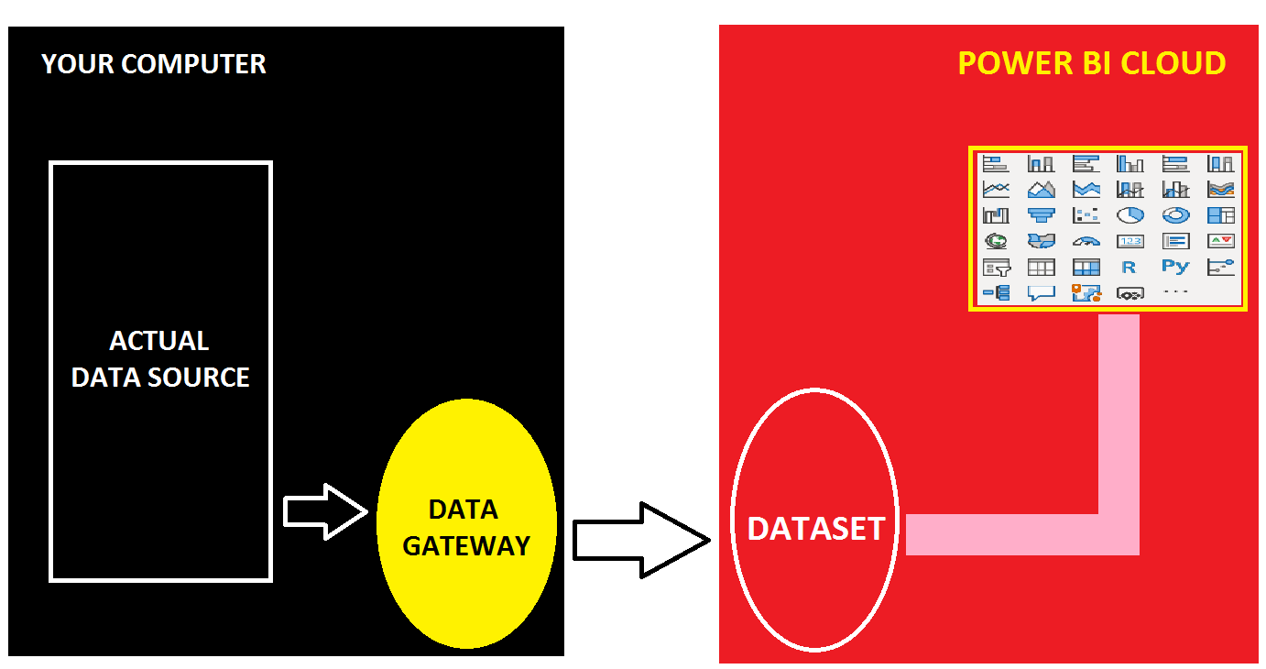

**STEP 1:** IDENTIFY THE SOURCE OF POWER BI REPORT IN YOUR COMPUTER (EX: AN EXCEL FILE).

DESIGN REPORT IN POWER BI DESKTOP > PUBLISH TO CLOUD.

**STEP 2:** DOWNLOAD DATA GATEWAY FROM : <https://powerbi.microsoft.com/en-us/gateway/>

SELECT "**STANDARD MODE**" GATEWAY [MULTI USER CONNECTIONS].

INSTALL THE GATEWAY > WHEN PROMPTED, **SIGN IN** TO POWER BI CLOUD.

WHEN PROMPTED, **REGISTER** THE GATEWAY ON YOUR COMPUTER > SPECIFY **GATEWAY NAME** & PASSWORD > CONFIGURE. GATEWAY RUNS WITH "**NT SERVICE\PBIEgwService**" > CLOSE.

**STEP 3**: FROM POWER BI CLOUD > TOP : RIGHT > SETTINGS > MANAGE GATEWAYS > SELECT ABOVE CREATED GATEWAY > ADD DATA SOURCE > SOURCE CONNECTION DETAILS [FILE PATH AND FILE NAME, EXTENSION], ACCES DETAILS [YOUR PC USER NAME, PASSWORD] > TEST CONNECTION.

**STEP 4**: FROM POWER BI CLOUD > WORKSPACE > DATASET : ACTIONS > SETTINGS > GATEWAY CONNECTION > SELECT REQUIRED GATEWAY AND MAP THE REQUIRED SOURCE CONNECTION > CLICK @ APPLY.

SCROLL DOWN > SCHEDULE REFRESH : ON > DEFINE THE SCHEDULE.

SENT NOTIFICATION EMAIL IF REFRESH FAILS > CLICK @ APPLY.

**STEP 5**: TO TEST THE REFRESH: FROM POWER BI CLOUD > WORKSPACE > DATASET : ACTIONS > REFRESH. THEN FROM POWER BI CLOUD > WORKSPACE > REPORT : REFRESH

**ITEM #21: WHAT ARE THE DIFFERENT REPORT ACTIONS (OPERATIONS) IN CLOUD?**

FILE: SAVE A COPY, DOWNLOAD, PRINT, SETTING

EXPORT : POWERPOINT, PDF, ANALYSE IN EXCEL

SHARE : REPORT, EMBED CODE (SECURE, PUBLIC), QR CODE

CHAT IN TEAMS

COMMENTS

SUBSCRIBE: SEND AUTOMATED EMAILS BASED ON A PREDEFINED SCHEDULE

EDIT

SEE RELATED CONTNET

OPEN LINEAGE VIEW

OPEN USAGE METRICS

PIN TO DASHBOARD

REFRESH

FAVORITE

**ITEM #22: WHAT ARE THE DIFFERENT DATASET ACTIONS (OPERATIONS) IN CLOUD?**

EXPORT : PRINT

SHARE : SHARE DASHBOARD TO OTHER POWER BI USERS. THEY CAN READ, REASHARE

SUBSCRIBE: SEND AUTOMATED EMAILS BASED ON A PREDEFINED SCHEDULE

COMMENTS

SHARE @ TEAMS

FAVORITE

ADD TILE [IMAGE OR VIDEO OR STREAMING DATASET]

SAVE A COPY

FEATURED

VIEW RELATED

USAGE METRICS

PERFORMANCE INSPECTOR

MOBILE VIEW

THEME

REFRESH

SETTINGS

**DATA FLOWS** : DATA FLOWS ARE POWER BI CLOUD ENTITIES USED FOR ETL OPERATIONS.

MEANS, DATA FLOWS CAN BE USED TO IMPLEMENT POWER QUERY IN POWER BI CLOUD.

STEP 1: GO TO POWER BI WORKSPACE > DATAFLOWS > + CREATE > DATAFLOW > ADD ENTITY >

CONNECT TO DATA SOURCE SCREEN : SELECT JSON (OR ANY OTHER DATA SOURCE TYPE) >

SPECIFY LOCATION OF ON-PREMISE, SELECT GATEWAY CONFIGURED ABOVE > SPECIFY ACCESS

CREDENTIALS > WE SEE "**EDIT QUERIES**" WINDOW > RIGHT CLICK QUERY > DUPLICATE.

QUERY 1 : CLICK @ RECORD 1 > CONVERT TO TABLE.

QUERY 2 : CLICK @ RECORD 2 > CONVERT TO TABLE.

SELECT QUERY > ... MORE OPTIONS > COMBINE TABLE > MERGE AS NEW > SELECT BOTH TABLES

INNER JOIN > OK. SAVE & CLOSE.

STEP 2: LAUNCH POWER BI > SIGN IN TO CLOUD > GET DATA > POWER BI DATA FLOWS.

**IMPORTS** & **UPLOADS**, **APP PUBLISH**

**ITEM #1: HOW TO CREATE NEW DATASETS WITH EXCEL FILE?**

POWER BI CLOUD > APP WORKSPACE > CLICK @ + NEW > UPLOAD FILE > LOCAL FILE > BROWSE FOR THE REQUIRED EXCEL FILE > OPEN > **IMPORT**. THIS CREATES A NEW **DATASET**.

WE CAN CREATE NEW REPORTS FROM THIS IMPORTED DATASET.

**ITEM #2: HOW TO USE THE IMPORTED EXCEL FILE?**

FROM POWER BI CLOUD > WORKSPACE > ALL CONENT OR DATASETS + DATA FLOW >

> MORE OPTIONS : CLICK ... IN CREATED DATASET > CREATE REPORT

**ITEM #3: HOW TO CREATE NEW WORKBOOKS WITH EXCEL FILE?**

POWER BI CLOUD > APP WORKSPACE > CLICK @ + NEW > UPLOAD FILE > LOCAL FILE > BROWSE FOR THE REQUIRED EXCEL FILE > OPEN > **UPLOAD**. THIS CREATES A NEW **WORKBOOK**.

**ITEM #4: HOW TO USE WORKBOOKS WITH EXCEL FILE?**

FROM POWER BI CLOUD > WORKSPACE > ALL CONENT > CLICK @ REQUIRED WORKBOOK > THIS RESULTS IN **EXCEL ONLINE** > SELECT REQURIED CELLS > **PIN**.

THIS RESULTS IN A DASHBOARD TILE.

**ITEM #5: WHAT IS THE DIFFERENCE BETWEEN FILE IMPORT AND FILE UPLOAD?**

FILE **IMPORT** : FOR CREATION OF NEW **DATASETS** AND GENERATION OF NEW REPORTS

FILE **UPLOAD** : FOR CREATION OF NEW "**WORKBOOK**" SOURCES BY UPLOADING EXCEL FILES

**ITEM #6: HOW WORKBOOKS ARE DIFFERENT FROM REPORTS IN POWER BI?**

**WORKBOOKS CAN BE USED TO DEFINE DASHBOARDS. WORKBOOKS DOES NOT DEPEND ON ANY DATASET BUT REPORTS ALWAYS REQUIRES DATASET.**

**ITEM #7: HOW TO PUBLISH THE ABOVE APP WORKSPACE?**

FROM POWER BI CLOUD > WORKSPACE > TOP : RIGHT > CREATE APP > SET A NAME, DESCRIPTION. IN NAVIGATION PAGE : CREATE ONE SECTION FOR REPORTS. ONE MORE SECTION FOR DASHBAORDS. SELECT EACH REPORT AND PLACE IT UNDER REPORTS SECTION.

SELECT EACH DASHBOARD > PLACE IT UNDER DASHBOARDS SECTION.

SET SECURITY : ENTIRE ORGANIZATION OR INDIVIDUAL POWER BI USERS > PUBLISH APP.

THEN WE SEE ONE URL :

**https://app.powerbi.com/Redirect?action=OpenApp&appId=889d8122-c5ab-470d-b55b-219f3fbc8a9a&ctid=3bc9fb10-6983-4ea4-9d63-16affeba3cee**

**APP PUBLISH:**

POWER BI APP CONTAINS:

1. REPORTS

2. DASHBOARDS

3. WORKBOOKS

FROM TOP @ RIGHT CORNER OF THE WORKSPACE > CREATE APP >

SETUP SCREEN: NAME, DESCRIPTION

NAVIGATION SCREEN: +NEW : SECTION > ARRANGE REPORTS, DASHBOARDS, WORKBOOKS

PERMISSIONS SCREEN: ENTIRE ORGANIZATION OR INDIVIDUAL POWER BI USERS

PUBLISH APP

THEN WE GET ONE APP URL.

TO VERIFY THE APPS:

POWER BI CLOUD > APPS PAGE @ LEFT.